LAB EXPERIMENTS (CSA4369) INTERNET PROGRAMMING

DAY:1

PROGRAM1:

***ImageMap.html***

<HTML>

<HEAD>

<TITLE>Image Map</TITLE> </HEAD>

<BODY>

<img src="india_map.jpg" use map="#metroid" ismap="ismap" > <map name="metroid"

id="metroid">

<area href="TamilNadu.html" shape="circle" coords="208,606,50" title="TamilNadu"/>

<area href="Karnataka.html" shape="rect" coords = "130,531,164,535" title ="Karnataka" />

<area href="AndhraPradesh.html" shape="poly" coords =

"227,490,238,511,230,536,198,535,202,503" title ="Andhra Pradesh" />

<area href="Kerala.html" shape="rect" coords = "154,606,166,621" title ="Kerala" /> </map>

</BODY>

</HTML>

***TamilNadu.html***

<HTML><HEAD>

<TITLE>About Tamil Nadu</TITLE>

</HEAD>

<BODY>

<CENTER><H1>Tamil Nadu</H1></CENTER> <HR>

<UL>

<LI>Area : 1,30,058 Sq. Kms.</LI>

<LI>Capital : Chennai</LI>

<LI>Language : Tamil</LI>

<LI>Population : 6,21,10,839</LI> </UL><hr>

<a href='ImageMap.html'>India Map</a>

</BODY>

</HTML>

***Karnataka.html***

<HTML>

<HEAD>

<TITLE>About Karnataka</TITLE> </HEAD>

<BODY>

<CENTER><H1>Karnataka</H1></CENTER>

<HR><UL>

<LI>Area : 1,91,791 Sq. Kms</LI>

<LI>Capital : Bangalore</LI>

<LI>Language : Kannada</LI>

<LI>Population : 5,27,33,958</LI>

</UL>

<hr>

<a href='ImageMap.html'>India Map</a>

</BODY>

</HTML>

***AndhraPradesh.html***

<HTML>

<HEAD>

<TITLE>About Andhra Pradesh</TITLE> </HEAD>

<BODY>

<CENTER><H1>Andhra Pradesh</H1></CENTER> <HR>

<UL>

<LI>Area : 2,75,068 Sq. Kms</LI>

<LI>Capital : Hyderabad</LI>

<LI>Language : Telugu</LI>

<LI>Population : 7,57,27,541</LI>

</UL>

<hr>

<a href='ImageMap.html'>India Map</a>

</BODY>

</HTML>

***Kerala.html***

<HTML>

<HEAD>

<TITLE>About Kerala</TITLE>

</HEAD>

<BODY>

<CENTER>

<H1>Kerala</H1></CENTER>

<HR>

<UL>

<LI>Area : 38,863 Sq. Kms.</LI>

<LI>Capital : Thiruvananthapuram</LI>

<LI>Language : Malayalam</LI>

<LI>Population : 3,18,38,619</LI>

</UL>

<hr>

<a href='ImageMap.html'>India Map</a>

</BODY></HTML>

5

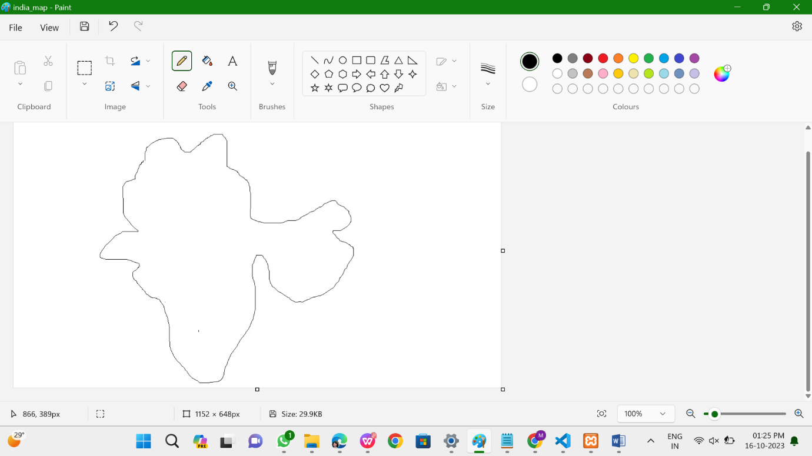



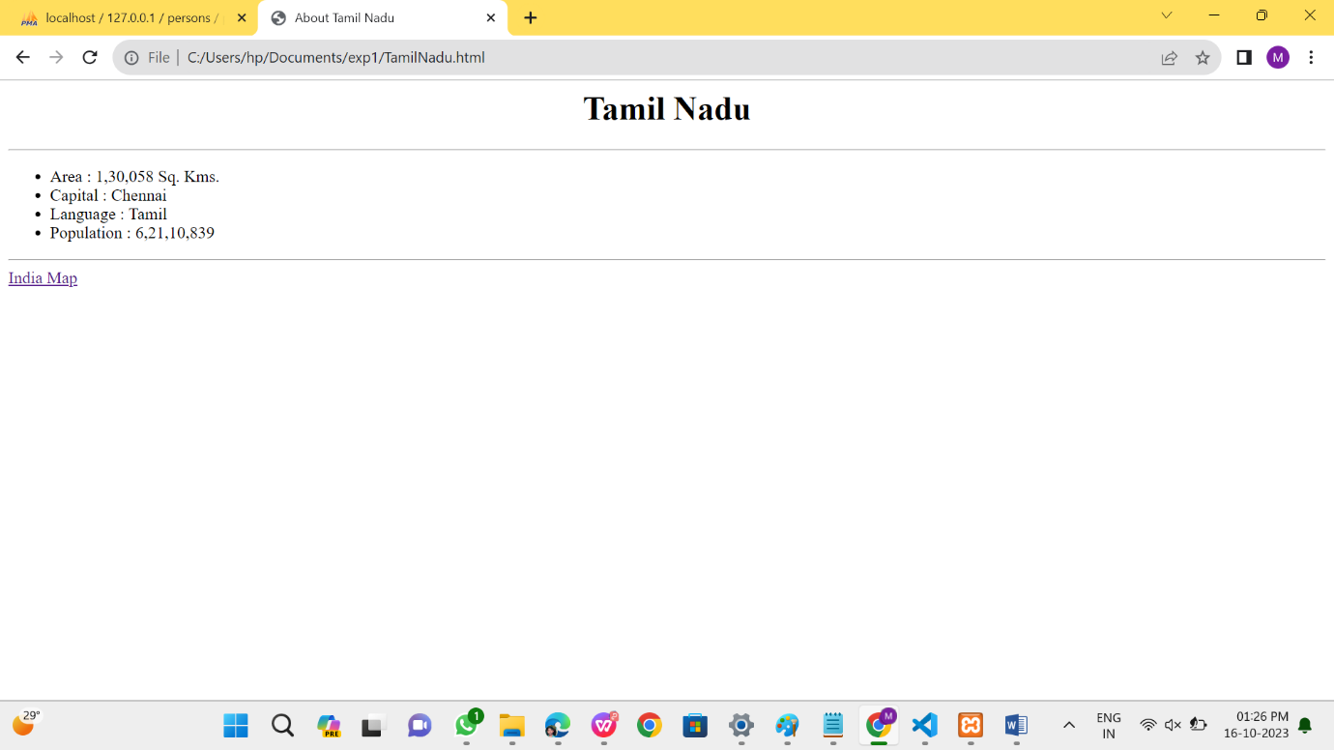

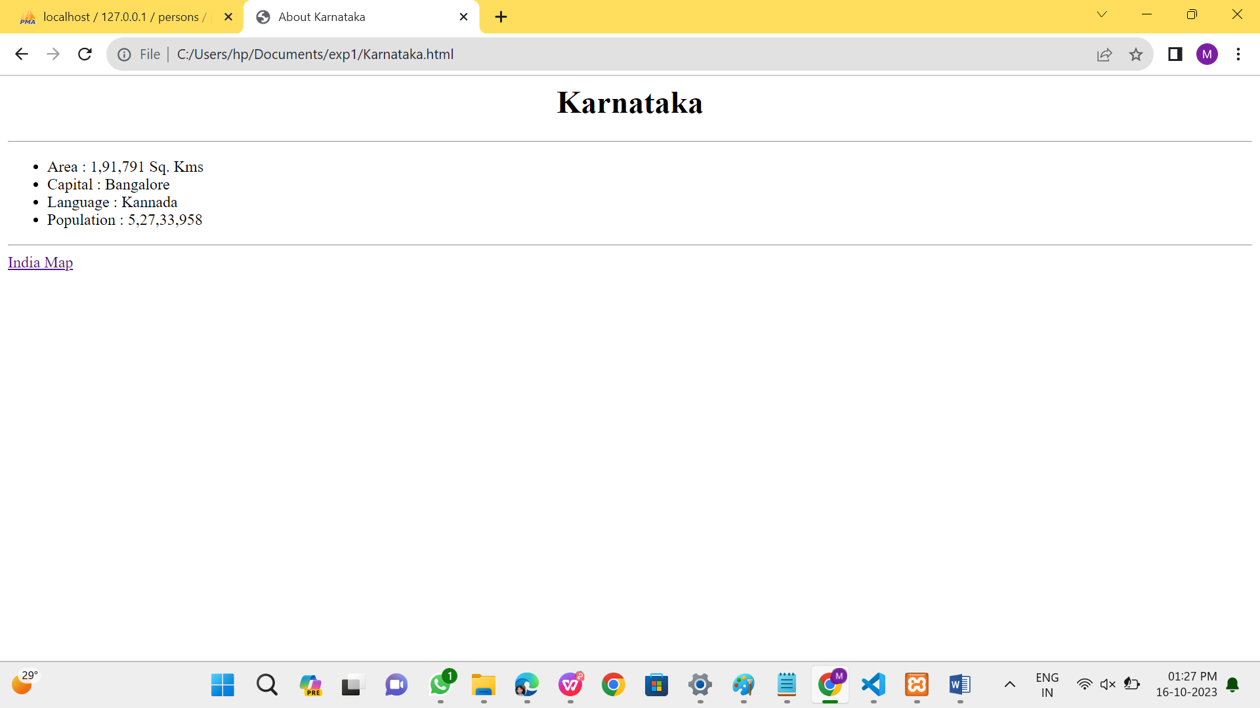

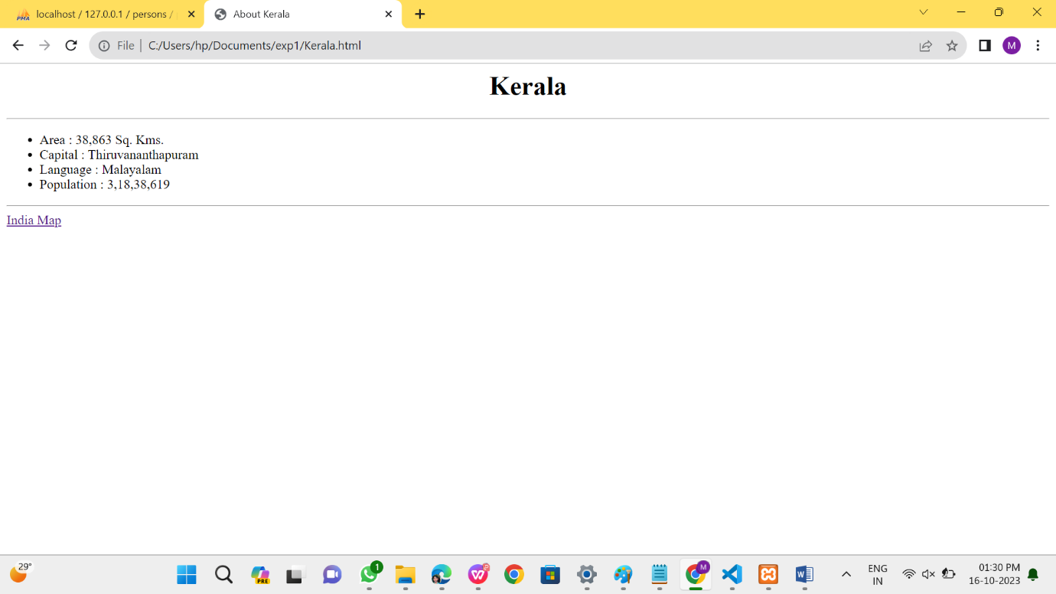

PROGRAM: 2

**XYZ.CSS:**

h3

{

font-family:arial;

font-size:20;

color:cyan

}

table{

border-color:green

}

td

{

font-size:20pt;

color:magenta

}

**HTML CODE:**

<html>

<head>

<h1>

<center>ALL STYLE SHEETS</center>

</h1>

<title>USE of INTERNAL and EXTERNAL STYLESHEETS </title>

<link rel="stylesheet" href="xyz.css" type="text/css">

<style type="text/css">

.vid

{

}

.ani

{

font-family:verdana;

font-style:italic;

color:red;

text-align:center

font-family:tahoma;

font-style:italic;8

}

font

{

}

ul

{

}

p

{

}

hr

{

}

font-size:20;

text-align:center;

font-family:georgia;

color:blue;

font-size:20

list-style-type:circle

font-family: georgia, serif;

font-size: x-small;

color: #ff9900; height: 1px

a:hover

{

color: #ff0000;

text-decoration: none

}

</style>

</head>

<body>

<h1 style="color:blue;margin-left:30px;">Welcome</h1> //In-line style Sheet

<ol style="list-style-type:lower-alpha">

<b>St.Anne‟s College of Engineering and Technology </b>

<br>

<br>

<br>

<li> EEE</li>

<li> ECE </li>

<li> MECH</li>

<li> CSE</li>

</ol>

<p style="font-size:20pt;color:purple">Details</p>

<p class="ani">St.Anne‟s College <br>It is approved by AICTE(All India Council for

Technical Education). It is affliated to Anna University.<br></p>

<h2 class="vid"> St.Anne‟s college of engineering </h2> <br>

<font>It is an ISO certified Institution

</font>

<br>

<br>

<font>

<h2>List of Courses offered</h2>9

<ul>

<li>Computer Science and Engineering</li>

<li>Ece</li>

<li>mech</li>

<li>eee</li>

</ul>

</font>

<h3>Results of cse students</h3>

<table width="100%" cellspacing="2" cellpadding="2" border="5"> <tr>

<th>S.NAME</th> <th>MARKS</th> <th>RESULT</th>

</tr>

<tr>

</tr>

<tr>

</tr>

<tr>

<td align="center">Suppriya</td> <td align="center">100</td>

<td align="center">pass</td>

<td align="center">Devishree</td> <td align="center">99</td>

<td align="center">pass</td>

<td align="center">Vinayagam</td> <td align="center">98</td>

<td align="center">pass</td> </tr>

</table>

</body>

</html>

OUTPUT:



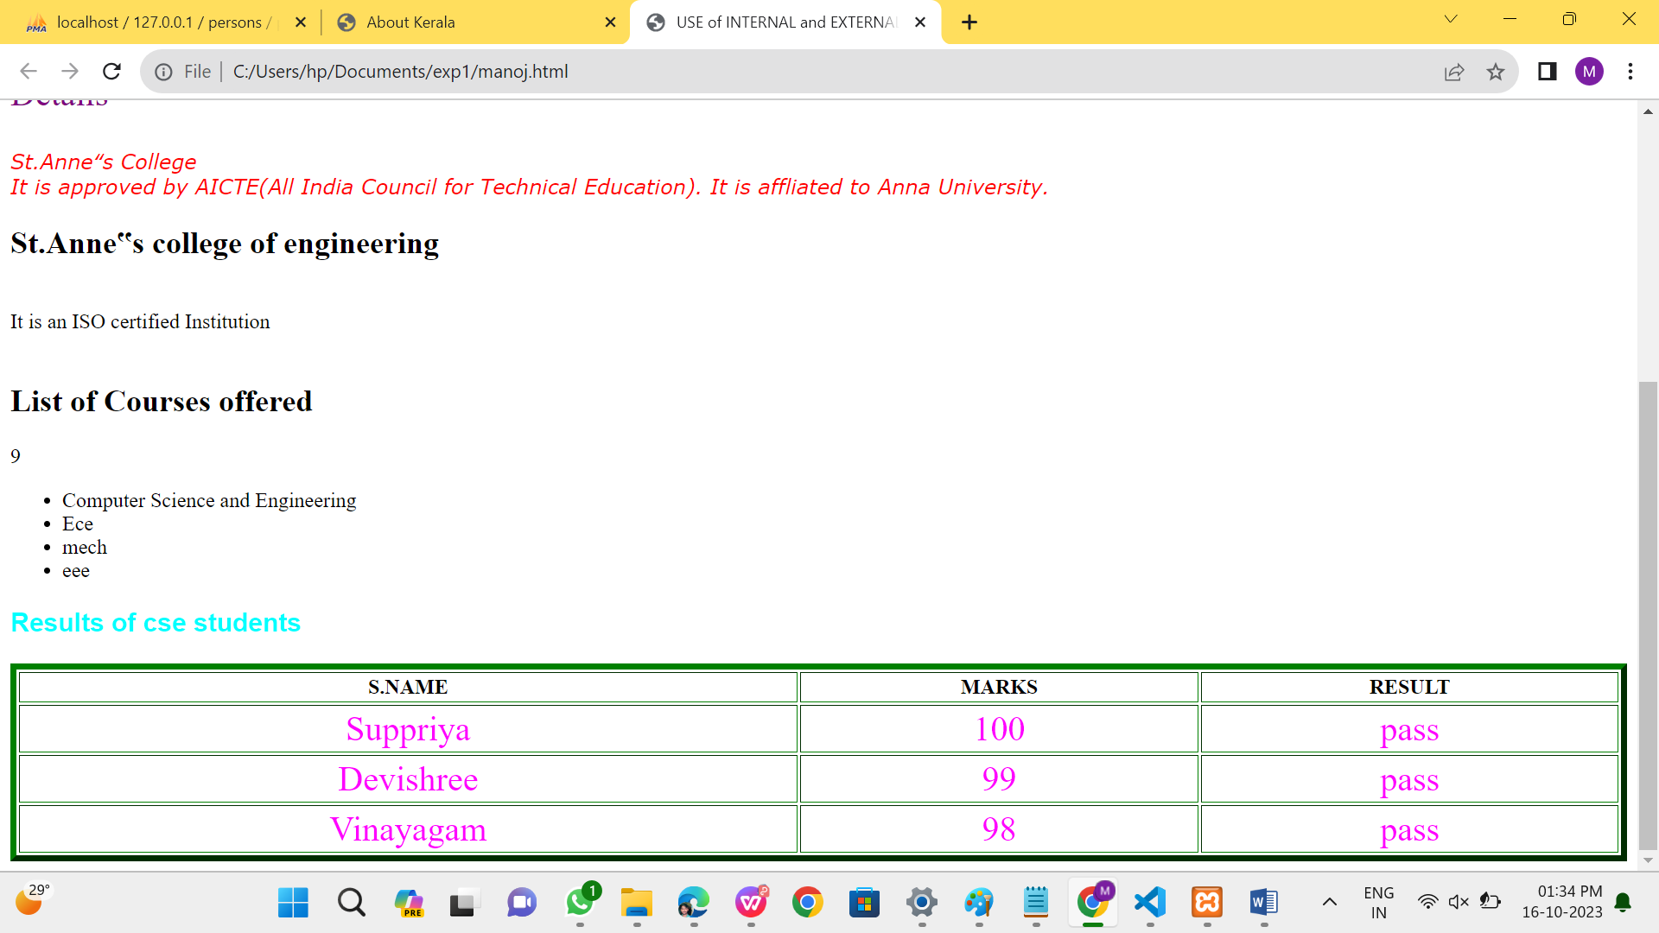

PROGRAM :3

**Main.html:**

<html>

<head>

<title> ONLINE BOOK STORES</title>

</head>

<body bgcolor="pink">

<marquee><h1 align=”center”><b><u><font color="white">

ONLINE BOOK STORAGE</u></font>

</b></h1></marquee>

<H2 ALIGN="CENTER">

<b><p><U><FONT COLOR="PURPLE">Welcome to online book storage.

Press login if you are having id otherwise press registration.</U></FONT></p></b></H2>

<H2> <FONT COLOR="WHITE"></FONT></H2>

<H3 ALIGN="CENTER">

<A HREF="reg.html"><BR><BR><FONT COLOR="black"><ITALIC>REGISTRATION

FORM</FONT></ITALIC><BR><BR>

<BR><BR><A HREF="profile.html"><FONT COLOR="black"><ITALIC>USER

PROFILE</FONT></ITALIC><BR>

<BR><BR><A HREF="login.html"><FONT COLOR="black"><ITALIC>USER

LOGIN</FONT></ITALIC><BR>

<BR><BR><A HREF="catalog.html"><FONT COLOR="black"><ITALIC>BOOKS

CATALOG</FONT></ITALIC><BR>

<BR><BR><A HREF="payment.html"><FONT

COLOR="black"><ITALIC>PAYMENT</FONT></ITALIC><BR>

<BR><BR><A HREF="Order.html"><FONT COLOR="black"><ITALIC>ORDER

CONFIRMATION</H3></FONT></ITALIC><BR>

</body>

</html>

**Login.html:**

<html>

<body bgcolor=”blue”><br><br><br>

<script language=”javascript”>

function validate()

{11

var flag=1;

if(document.myform.id.value==""||document.myform.pwd.value=="")

{

alert("LoginId and Password must be filled")

flag=0;

}

if(flag==1)

{

alert(“VALID INPUT”);

window.open("catalog.html","right");

}

else

{

alert(“INVALID INPUT”);

//document.myform.focus();

}

}

</script>

<form name=”myform”>

<div align=”center”><pre>

LOGIN ID:<input type=”text” name=”id”><br>

PASSWORD:<input type=”password” name=”pwd”>

<br><br>

</pre>

<input type=”button” value=”ok” onClick=”validate()”>

<input type=”reset” value=”clear”>

</div>

</form>

</body>

</html>

**Reg.html:**

<html>

<body bgcolor=”blue”><br><br>

<script language=”javascript”>

var str=document.myform.phno.value;

var x;

if(flag==1)

{

}

else

{

}

}

alert("VALID INPUT");

alert("INVALID INPUT");

document.myform.focus();

</script>

<form name="myform">

<div align="center"><pre>

NAME :<input type="text" name="name"><br>

ADDRESS :<input type="type" name="addr"><br>

CONTACT NUMBER:<iput type="text" name="phno"><br>

LOGINID :<input type="text" name="id"><br>

PASSWORD :<input type="password" name="pwd"></pre><br><br>

</div><br><br>

<div align="center">

<input type="submit" value="ok" onClick="validate()">

<input type="reset" value="clear">

</form></body></html>

**Catalog.html:**

<html>

<body bgcolor="pink"><br><br><br>

<div align="center">

<pre>

BOOK TITLE:<input type="text" name="title"><br>

</pre><br><br>

</div>

<br><br>

<div align="center">

<input type="submit" value="ok" name="button1">

<input type="reset" value="clear" name="button2">

</body>

</html>

**Order.html**:

<html>

<body bgcolor="pink"><br><br><br>

<div align="center"><pre>

LOGIN ID :<input type="text" name="id"><br>

TITLE :<input type="text" name="title"><br>

NO.OF BOOKS :<input type="text" name="no"><br>

COST OF BOOK:<input type="text"name="cost"><br>

DATE :<input tpe="text" name="date"><br></pre><br><br>

</div>

<br><br>

<div align="center">

<input type="submit" value="ok" name="button1">

<input type="reset" value="clear" name="button2">

</body>

</html>

**Payment.html:**

<html>

<body bgcolor="pink"><br><br><br>

<script language="javascript">

function validate()

{

var flag=1;

if(document.myform.id.value==""||

document.myform.pwd.value==""||

document.myform.amount.value==""||

document.myform.num.value=="")

{

1213

flag=0;

}

var str=document.myform.amount.value;

var x;

for(var i=0;i<str.length;i++)

{

x=str.substr(i,1);

if(!(x<=9))

{

flag=0;

break;

}

}

str=document.myform.num.value;

for(var i=0;i<str.lenght;i++)

{

x=str.substr(i,1);

if(!(x<=9))

{

flag=0;

break;

}

}

if(flag==1)

{

}

else

{

}

}

alert("VALID INPUT");

alert("INVALID INPUT");

document.myform.focus();

</script>

<form name="myform">

<div align="center"><pre>

LOGIN ID :<input type="text" name="id"><br>

PASSWORD :<input type="password" name="pwd"><br>

AMOUNT :<input type="text" name="amount"><br>

CREDITCARDNUMBER:<input type="PASSWORD" name="num+"><br></pre><br><br>

</div>

<br><br><div align="center">

<input type="submit" value="ok" onClick="validate()">

<input type="reset" value="clear">

</form>

</body>

</html>

**Profile.html:**

<html>

<body bgcolor="pink"><br><br><br>

<script type="text/javascript">

function validate()14

{

var flag=1;

if(document.myform.id.value==""||

document.myform.pwd.value=="")

{

flag=0;

}

if(flag==1)

{

}

else

{

}

}

alert("VALID INPUT");

alert("INVALID INPUT");

document.myform.focus();

</script>

<form name="myform">

<div align="center"><pre>

LOGIN ID :<input type="text" name="id"><br>

PASSWORD:<input type="password" name="pwd"></pre><br><br>

</div>

<br><br>

<div align="center">

<input type="submit" value="ok" onClick="validate()">

<input type="reset" value="clear" >

</form>

</body></html>

OUTPUTS:

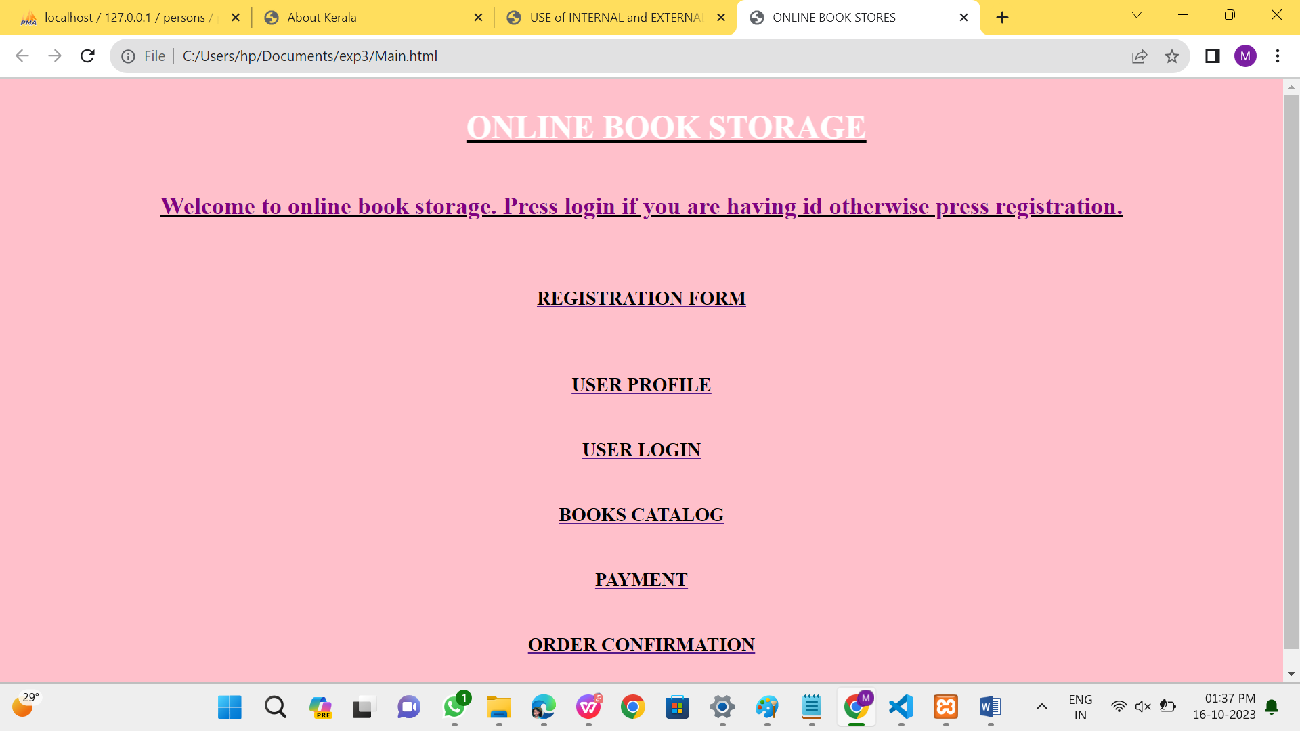

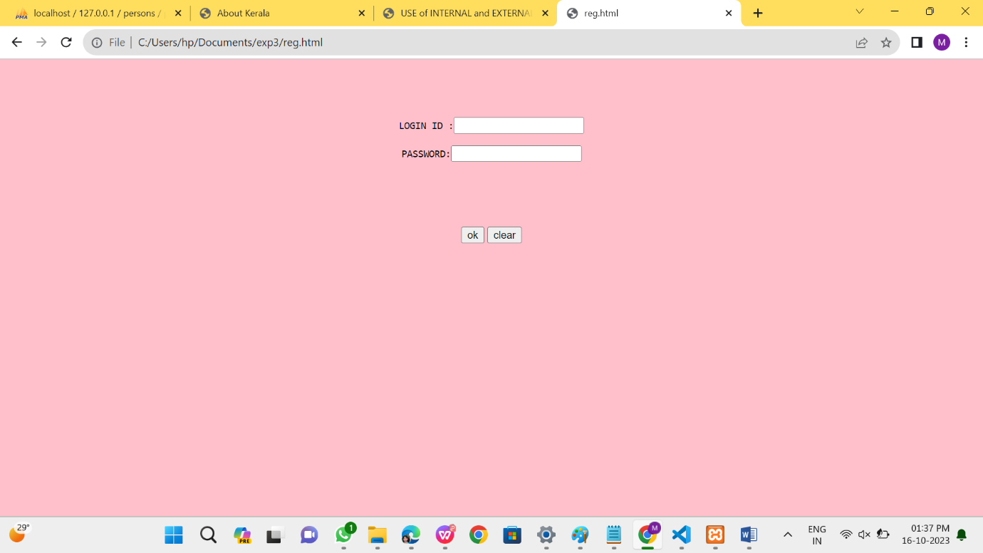

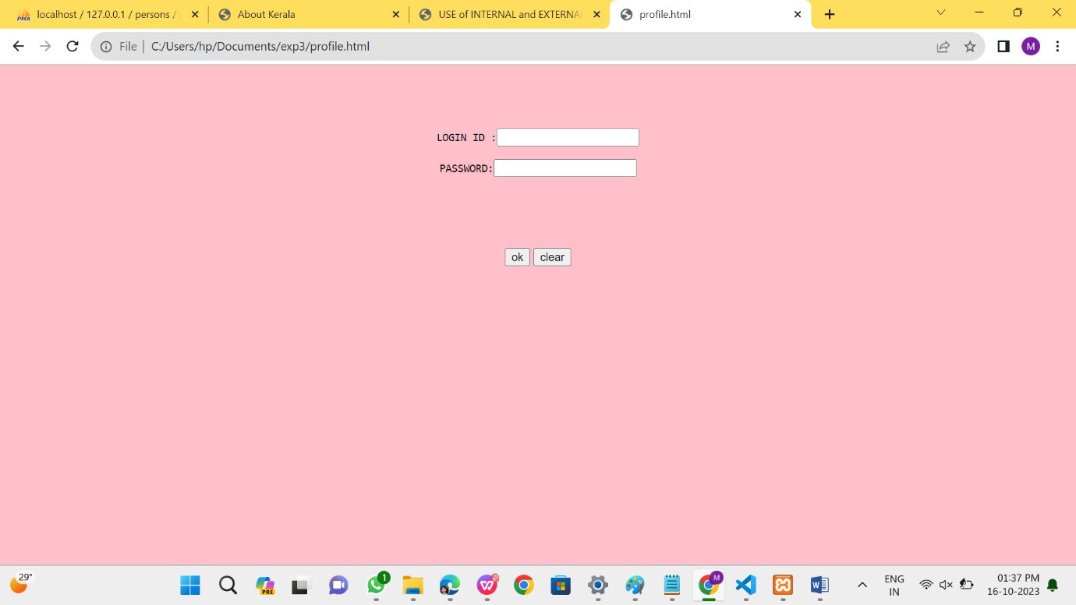

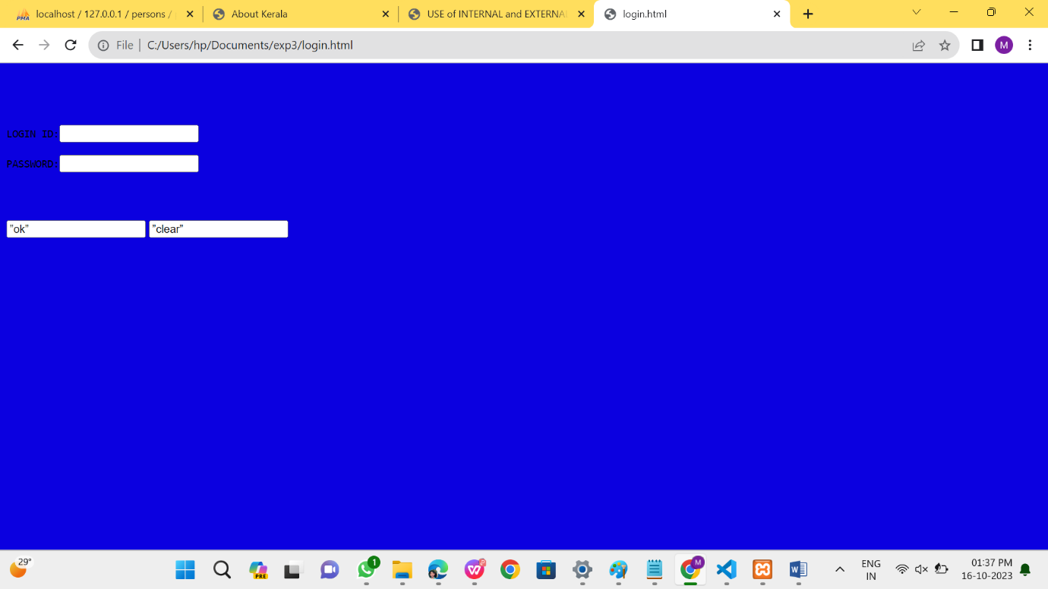

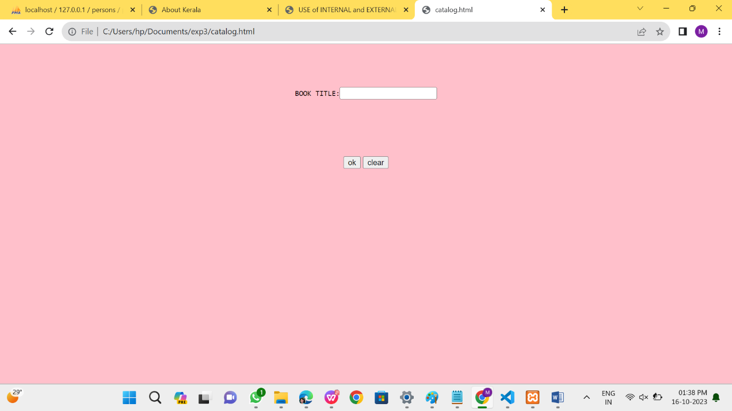

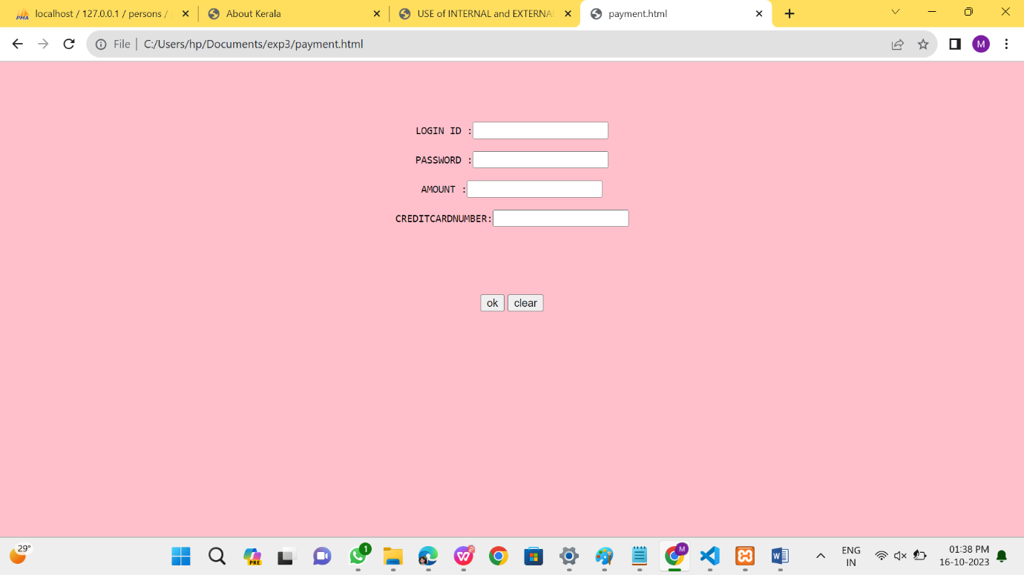

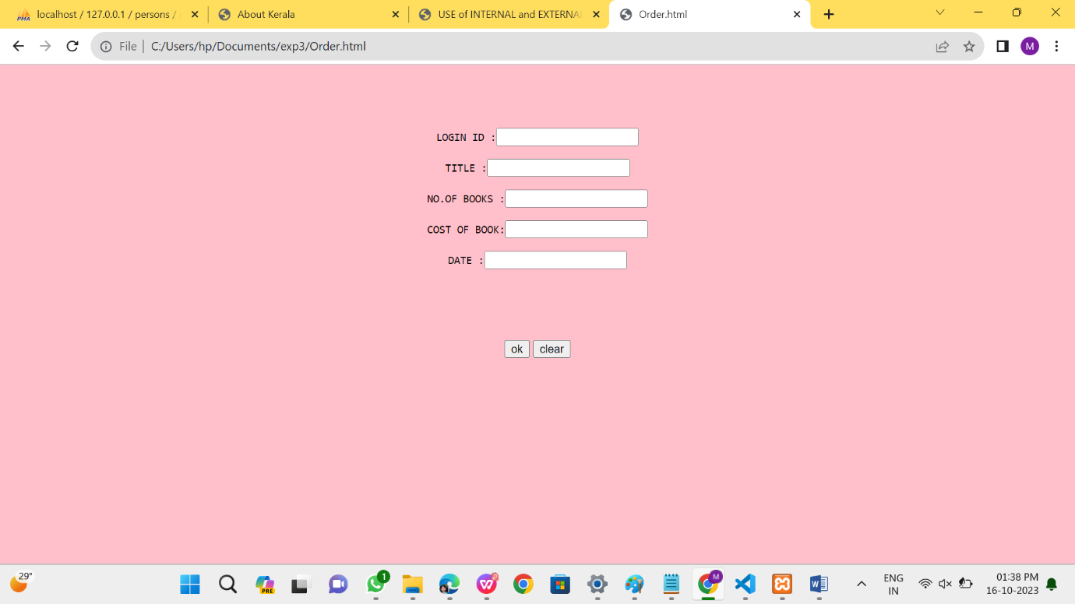

PROGRAM:9A

<!DOCTYPE HTML>

<html>

<head>

<style>

.error {color: #FF0000;}

</style>

</head>

<body>

<?php

$nameErr = $emailErr = $genderErr = $websiteErr = "";

$name = $email = $gender = $comment = $website = "";

if ($_SERVER["REQUEST_METHOD"] == "POST") {

if (empty($_POST["name"])) {

$nameErr = "Name is required";

} else {

$name = test_input($_POST["name"]);

if (!preg_match("/^[a-zA-Z-' ]*$/",$name)) {

$nameErr = "Only letters and white space allowed";

}

}

if (empty($_POST["email"])) {

$emailErr = "Email is required";

} else {

$email = test_input($_POST["email"]);

if (!filter_var($email, FILTER_VALIDATE_EMAIL)) {

$emailErr = "Invalid email format";

}

}

if (empty($_POST["website"])) {

$website = "";

} else {

$website = test_input($_POST["website"]);if (!preg_match("/\b(?:(?:https?|ftp):\/\/|www\.)[-a-z0-9+&@#\/%?=~_|!:,.;]*[-a-z0-

9+&@#\/%=~_|]/i",$website)) {

$websiteErr = "Invalid URL";

}

}

if (empty($_POST["comment"])) {

$comment = "";

} else {

$comment = test_input($_POST["comment"]);

}

if (empty($_POST["gender"])) {

$genderErr = "Gender is required";

} else {

$gender = test_input($_POST["gender"]);

}}

function test_input($data) {

$data = trim($data);

$data = stripslashes($data);

$data = htmlspecialchars($data);

return $data;

}

?>

<h2>PHP Form Validation Example</h2>

<p><span class="error">* required field</span></p>

<form method="post" action="<?php echo

htmlspecialchars($_SERVER["PHP_SELF"]);?>">

Name: <input type="text" name="name" value="<?php echo $name;?>">

<span class="error">* <?php echo $nameErr;?></span>

<br><br>

E-mail: <input type="text" name="email" value="<?php echo $email;?>">

<span class="error">* <?php echo $emailErr;?></span>

<br><br>

Website: <input type="text" name="website" value="<?php echo $website;?>">

<span class="error"><?php echo $websiteErr;?></span>

<br><br>

Comment: <textarea name="comment" rows="5" cols="40"><?php echo

$comment;?></textarea>

<br><br>

Gender:

<input type="radio" name="gender" <?php if (isset($gender) &&

$gender=="female") echo "checked";?> value="female">Female

<input type="radio" name="gender" <?php if (isset($gender) && $gender=="male")

echo "checked";?> value="male">Male

<input type="radio" name="gender" <?php if (isset($gender) && $gender=="other")

echo "checked";?> value="other">Other

<span class="error">* <?php echo $genderErr;?></span>

47<br><br>

<input type="submit" name="submit" value="Submit">

</form>

<?php

echo "<h2>Your Input:</h2>";

echo $name;

echo "<br>";

echo $email;

echo "<br>";

echo $website;

echo "<br>";

echo $comment;

echo "<br>";

echo $gender;

?>

</body>

</html>

OUTPUTS:

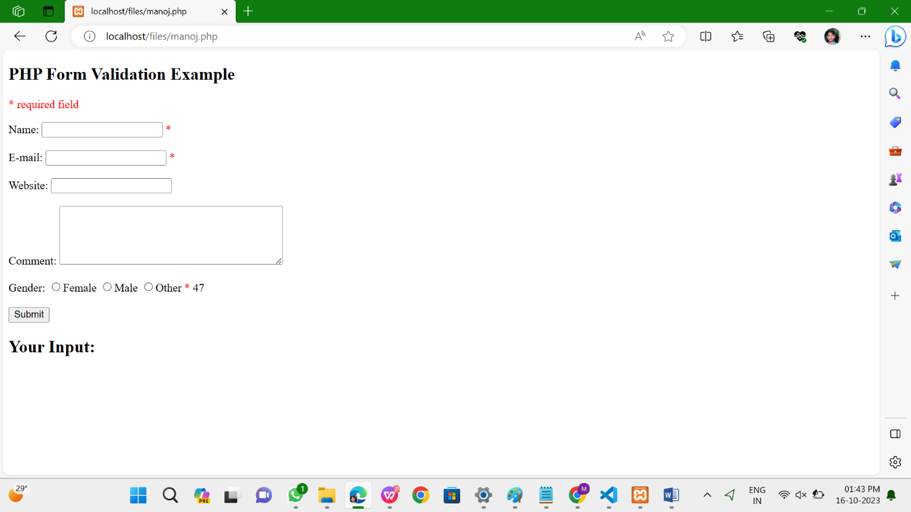

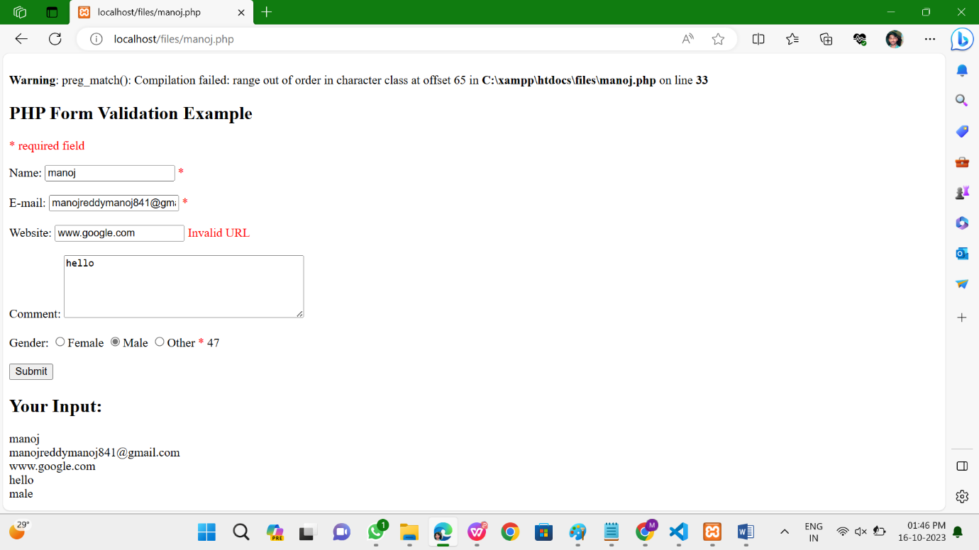

PROGRAM 9B:

**index.php:**

<!DOCTYPE html>

<html>

<head>

<style>

.error {color: #FF0000;}

</style>

</head>

<body>

<?php

$nameErr = $emailErr = $genderErr = $websiteErr = "";

$name = $email = $gender = $comment = $website =$result= "";

if ($_SERVER["REQUEST_METHOD"] == "POST") {

if (empty($_POST["name"])) {

$nameErr = "Name is required";

} else {

$name = test_input($_POST["name"]);

if (!preg_match("/^[a-zA-Z ]*$/",$name)) {

$nameErr = "Only letters and white space allowed";

}

}if (empty($_POST["email"])) {

$emailErr = "Email is required";

} else {

$email = test_input($_POST["email"]);

if (!filter_var($email, FILTER_VALIDATE_EMAIL)) {

$emailErr = "Invalid email format";

}

}

if (empty($_POST["website"])) {

$website = "";

} else {

$website = test_input($_POST["website"]);

if (!preg_match("/\b(?:(?:https?|ftp):\/\/|www\.)[-a-z0-9+&@#\/%?=~_|!:,.;]*[-a-z0-

9+&@#\/%=~_|]/i",$website)) {

$websiteErr = "Invalid URL";

}

}

if (empty($_POST["comment"])) {

$comment = "";

} else {

$comment = test_input($_POST["comment"]);

}

if (empty($_POST["gender"])) {

$genderErr = "Gender is required";

} else {

$gender = test_input($_POST["gender"]);

}

$servername = "localhost";

50$username = "root";

$password = "";

$dbname = "iplab";

$conn = new mysqli($servername, $username, $password, $dbname);

if ($conn->connect_error) {

die("Connection failed: " . $conn->connect_error);

}

$sql = "INSERT INTO register (name, email,website,comments,gender)

VALUES ('$name', '$email', '$website','$comment', '$gender')";

if ($conn->query($sql) === TRUE) {

$result="New Record Inserted Successfully";

} else {

echo "Error: " . $sql . "<br>" . $conn->error;

}

$conn->close();

}

function test_input($data) {

$data = trim($data);

$data = stripslashes($data);

$data = htmlspecialchars($data);

return $data;

}

?>

<h2>Registration Form</h2>

<p><span class="error">* required field</span></p>

<form method="post" action="<?php echo

htmlspecialchars($_SERVER["PHP_SELF"]);?>">

Name: <input type="text" name="name">

51<span class="error">* <?php echo $nameErr;?></span>

<br><br>

E-mail: <input type="text" name="email">

<span class="error">* <?php echo $emailErr;?></span>

<br><br>

Website: <input type="text" name="website">

<span class="error"><?php echo $websiteErr;?></span>

<br><br>

Comment: <textarea name="comment" rows="5" cols="40"></textarea>

<br><br>

Gender:

<input type="radio" name="gender" value="female">Female

<input type="radio" name="gender" value="male">Male

<span class="error">* <?php echo $genderErr;?></span>

<br><br>

<input type="submit" name="submit" value="Submit">

</form>

<?php

echo $result;

?>

</body>

</html>

OUTPUTS:

